

**IMPORTANCE OF COSTS OF RISKS IN MATERIAL MANAGEMENT**

Ewa KULIŃSKA

Opole University of Technology, Faculty of Production Engineering and Logistics Institute of Industrial Processes Generating Capacity, Department of Logistics, Opole, Poland

e-mail: [e.kulinska@po.opole.pl](mailto:e.kulinska@po.opole.pl)

***Abstract:*** The article is an analysis of materials management in different areas of functioning of manufacturing enterprises, with particular reference to the costs generated by it and all possible risk fac- tors. The overall objective is to demonstrate, on the basis of the study in the furniture industry, that the oc- currence of a risk factor in one area of a company has financial consequences for even a few more stages of the process. This affects the calculation of the actual cost of implementing the process and naturally car- ries consequences in the profit achieved by the company. For the analysis, the well-known algebraic princi- ple of logic characterization of V.A. Gorbatov was applied.

***Keywords:*** materials management, logistics processes, risk, risk management, characterization principle, manufacturing enterprises, total cost, actual cost.

# Introduction

While treating an enterprise as a system of mutually interacting logistics processes in the sense of the flow of material and information streams, the reliability of functioning of each of the processes is of crucial importance. Materials management is one of the key supporting processes. It is due to the fact that materials and products, regardless of their actual character, ap- pearing in any enterprise engage certain material and personnel resources as well as generate certain logistic costs, which influence the business result significantly.

A comprehensive analysis of materials management is the basis for distinguishing risk factors of the pro- cess, which gives rise to implementation of the risk management in the given enterprise. Securing the prop- er functioning of logistics processes, including material management, through risk management has a significant impact on the level of the net profit achieved.

An analysis of materials management in individual spheres of functioning of manufacturing companies with particular emphasis on its costs and possible risk factors is the purpose of this article.

The general objective is to demonstrate on the basis of the studies conducted in the furniture industry, that the occurrence of a risk factor in one area of the business activity has financial consequences for several consecutive stages of the implementation process. It affects the calculation of actual costs of the imple- mentation of the given process and consequently has

an impact on the profit achieved by the enterprise. The V.A. Gorbatov Characterization Principle well- known from algebra of logic was applied in the analy- sis.

# The problem of costs in materials manage- ment

The coordination of processes related to materials man- agement is one of the most difficult logistical tasks. Materials management applies to all spheres of functioning of manufacturing companies and largely determines quality, time, flexibility and many other factors essential in the parameterization of main pro- cesses. The specificity of collection, storage and allo- cating materials in individual spheres of functioning of manufacturing companies is a little bit different and each of them has its critical points, at which risk factors and disorders of continuity of the process im- plementation may appear with even a little careless- ness.

The materials of the supply sphere and relatively high maintenance costs associated with them give rise to naturally distinguished different division criteria and different categories of supply materials in every enterprise. A general model for classification of the materials of the supply sphere, including the influence on the financial result, share in costs and the impact of risk factors (see Fig. 1).

Influence on the financial result

The biggest

Big

Little

Negligible

Share in costs

The biggest

Big

Little

Negligible

Influence of risk factors

The biggest

Big

Little

Negligible

Other

Available

Difficult to obtain

Strategic

**MATERIALS OF THE SUPPLY SPHERE**

Figure 1. Classification of the materials of the supply sphere - a model approach

Regardless of the industry in which the company oper- ates, it is possible to distinguish groups of strategic materials in the supply sphere, which are difficult to obtain, available and others specific to the industry, geographical location and such. As it can be seen on the presented figure, the strategic materials affect the achieved financial result to the greatest extent, are the most expensive ones, as well as the presence of a risk factor in this group causes the most severe consequences. Most often, these are materials, which are not only a base for manufactured products but are also a “showpiece” determining the brand and the qual- ity. Therefore, while expecting a net profit on business activities, it is necessary to pay special attention to the management of these materials.

The materials difficult to obtain, even though they do not have strategic importance for functioning of companies, play a significant role in maintaining continuity of production. Therefore, it is very important to maintain a “safe” supply level of these materials.

The management of the materials, which are generally available, does not require meeting very rigorous re- quirements, as in the case of the two previous groups. These materials play the role of a stimulus in the struc- ture of economic processes; they are generally availa- ble in the market that gives rise to the possibility of negotiating their prices and delivery conditions,

that is, the factors, which are important from the point of view of the costs and the impact on the financial result.

The physical flow in the logistics sphere of the produc- tion, in terms of the material management, includes:

* transfer of raw materials, semi-finished products, spare parts and finished products,
* securing technological supplies and stocks of the work in progress.

There are shown two groups of materials in Fig. 2; a dynamic and a static one. The dynamic one is a group of materials that is being used in the production process at the particular moment; these materials accompany value creation (net profit). The static group consists of stocks of work in progress, that is, these are genera- tors of costs. It is on the correct functioning of the ma- terials management that the continuity and appropriate intensity of the production depends. The minimization of stocks of work in progress at the operational level is of utmost importance in this sphere, since it is directly associated with the minimization of costs of the frozen capital and reduction of the costs of maintaining stock, which translates into liquidity and efficiency of the whole production process in turn.

Creating the value



**MATERIALS OF THE PRODUCTION SPHERE**

Stock store

materials

products

Store of finished

products

Inter-department stocks

Intra-department stocks

Current

Reserve

Cyclical

Not cyclical

Operational

Interoperational

Generating

costs

Transport Compensating

Emergency

Revolving

**STOCKS OF WORK‐IN‐PROGRESS**

Products

Semi-finished

Parts

Materials

Raw

Figure 2. Classification of the materials of the production sphere - a model approach

A reduction in the level of stocks of work-in-progress and of frozen working capital as well as of maintenance costs of stocks are essential for generating costs and thus for the net profit. Collecting, storing and controlling such a comprehensive system of stocks of work-in-progress entail large time, technical and organizational efforts and, as a result, also high costs.

With regard to the management of the materials in the distribution sphere, it can be considered in a narrow and wide view.

The narrow view, associated with the supply side of the business activity, is concentrated on:

* + tasks related to the physical, time-spatial flow of finished products from the producer to the end user
  + activities related to the logistic determinants of sale transactions in the sphere of stocks management as well as transport and handling processes.

A wide range of materials processes in the distribution sphere includes: ordering goods and their transport, storing and shaping supplies, packing finished products and maintaining delivery channels (see Fig. 3).

**MATERIALS OF THE DISTRIBUTION SPHERE**

Market (7 W)

Others

Semi-finished

products

Finished

products

Generators of costs

Transport, handling

Warehouse management

Stock management

Packing products

Appearing of risk factors

Figure 3. Classification of materials of the distribution sphere - a model approach

The problems of material management of the distribu- tion sphere of goods, products and finished products should be considered as a whole, in accordance with the logistic approach, as an essential link of a logistic chain of flows of material goods. It is very important, since there are many decision-making problems affect- ing costs related to materials management such as:

* logistic management of processes of distribution of goods,
* physical control over the flow of goods from a pro- ducer to a consumer,
* developing physical distribution processes of prod- ucts and finished products,
* determining optimal inventories in indirect links of distribution channels,
* determining the number and the length of distribu- tion channels and the number of indirect links (plac- es of storage),
* maintaining an adequate level of finished products,
* determining the level and the structure of stocks.

The strategic objective of the materials management of the distribution sphere is to minimize the total costs of logistics and distribution, while maintaining smoothness of economic processes and standards of the customer service.

To sum up, the costs of materials management should not be identified exclusively with prices of the pur- chased materials. Additional costs of transport and storage, different types of warehouses, accurate fore- casting restocking and correct schedules for orders are equally crucial factors, which require consideration. The logistics management of stocks is a comprehensive arrangement of the flow of materials and information. It should satisfy the needs of customers and enable reduction in the costs of the management of materials. A properly implemented strategy of materials manage- ment should enable integration of the materials and information market as well as timeliness and com- pleteness of the services provided, minimization of stocks, increasing throughput, high flexibility of operations and supply, minimization of the order cycle time and the most important - cost savings.

The logistic approach to the management of the eco- nomic sphere, in particular, requires compliance with the principle of thinking about the whole; it means that while arranging for materials management, the issues of material supplies, transport, storing, packing and many others should be taken into account.

Such an extensive system, even if it is managed in the best way, cannot be free of risk factors. The risk man- agement in this sphere is particularly important, since materials management itself generates high costs. Eve- ry additional factor, which extends time or increases costs, may significantly affect the profitability of the materials management and hence influence the net profit achieved.

# The analysis of risk factors at strategic points

Risk factors appear in each of the logistic processes in enterprises; in particular, a lot of them affect the materials management sphere. Regardless of the fact to which sphere the risk management applied is to, it has to be a continuous process, that is, a logically ordered sequence of successive events, actions, decisions and arrangements.

The risk management should cover all activities of the enterprise; concentrate on the identification of potential events that could negatively affect the objectives of the enterprise, the assessment of the risk associated with it and then defining and implementing solutions aimed at reducing the risk and keeping it within controlled limits [12].

The risk factors can be identified at different levels of detail. It is easier to identify such risk factors, which may appear in every operational sphere of materials management in the enterprise (see Fig. 4).

However, if the system of the risk management is sup- posed to be effective, it is much better to analyze the whole process of the material management in individu- al logistic spheres of functioning of the enterprise for the presence of risk factors. On the basis of schematics described in the previous subsection, it is possible to distinguish the following risk factors of the material management (see Tab. 1).

Certainly, such a specification is not the only one pos- sibility and does not exhaust the catalogue of risk fac- tors, which may appear in this field. It is rather a starting point for deliberations in this respect.

The analysis of risk factors can be carried out much more effectively on a real example. This article also includes the costs of the risk factors analyzed, which appeared in the materials management of an enterprise of the furniture industry functioning in the Opole voi- vodeship.

Table 1. The selected risk factors of material management

|  |  |
| --- | --- |
|  | **RISK FACTORS** |
| **SUPPLY SPHERE** | Strategic materials:   * forecasting market needs, * errors while planning the supply level, * choice of suppliers, * negotiating terms of delivery, * negotiating supply prices, * supply reliability, * regularity of supplies, * impact of random factors, * seasonality of production, * wrong level of stocks. |
| **SUPPLY SPHERE** | Materials difficult to obtain in the market:   * risk of supplies, * disturbances in intensity of technological processes, * disturbances of smoothness of technological processes, * high costs of collection, * high maintenance costs, * errors in short-term forecasts, * errors in plans of demand and supply; * errors in recruitment of staff at the operational level.   Materials available in the market:   * lack of a stable supply strategy, * lack of a flexible pricing policy, * errors in negotiations with suppliers, * collection of a very high level of stocks, * errors in staff recruitment at lower levels of the organization. |
| **PRODUCTION SPHERE** | * too low or too high level of interoperable stocks, * errors in inventory control in the course of production, * high dynamic of creation, rotation rate, high cyclicality of consumption, * running out of stock on one or several working stations, * too-long time of interoperable logistic procedures related to the transfer of materials, * errors in the division of labor, * errors in connecting work positions, * errors in connecting production units (slots), * lack of one-way flow of physical materials, * too many logistic channels. |
| **DISTRIBUTION SPHERE** | * problems with selling manufactured products, goods and services, * errors in ordering and transport of goods, * errors in storage and shaping stocks, * improper packaging of finished products, * lack of proper maintenance of distribution channels. |

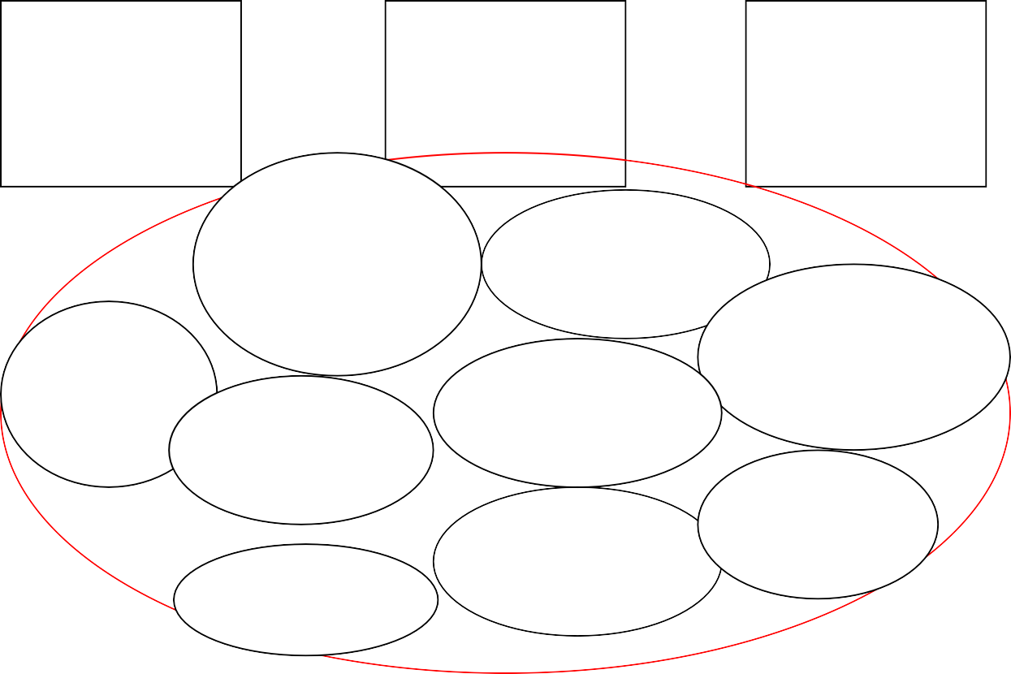

**The risk factors for the materials management sphere**

Materials of the supply

sphere

Materials

of the production sphere

Materials

of the distribution sphere

there is no division into warehouses for materials of fast

and slow rotation

no marks

of tagging fields

no classification of materials

no detailed data on individual stocks

system of the material quality control

appearance

of defects in materials

possession

of unnecessary stocks

hidden defects of materials

errors related

to the human factor

Figure 4. The selected risk factors for the materials management sphere

**4 The materials management of an enterprise of the furniture industry**

Based on the data of an enterprise in the furniture in- dustry, six risk factors important from the point of view

of the materials management were identified within logistic processes carried out. It is on this basis that the propositional function was created:

ZPx(P1, P2,…,P52) = X1 X5 V X2 V X1 X2 X3 X4 V X1 X2 X4 V X1 X3 X5 V X1 X2 X6

Each of the risk factors of the furniture company X1 X2 X3 X4 X5 X6 includes the information on the frequency (probability) of the appearance of risk factors and po- tential effects (measured with the maximum cost

of eliminating the effects of the appearance of the risk factors). While taking the analyzed enterprise into con- sideration, these values developed as follows (see Table 2).

Table 2. The juxtaposition of the probability and effects of the appearance of risk factors in the ZPx function

*(source: own study based on research results)*

|  |  |  |  |  |
| --- | --- | --- | --- | --- |
| **THE AREA**  **OF THE APPEARANCE OF RISK FACTORS** | **PROPOSITIONAL VARIABLE** | **2013** | | **QUANTITY * COST** |
| **QUANTITY** | **MAX COST** |
| SUPPLIES | X1 | 15 | 2,000 | 30,000 |
| X5 | 60 | 5,000 | 300,000 |
| PRODUCTION | X2 | 41 | 3,500 | 143,500 |
| DISTRIBUTION | X1 | 15 | 2,000 | 30,000 |
| X2 | 41 | 3,500 | 143,500 |
| X3 | 48 | 2,500 | 120,000 |
| X4 | 5 | 2,000 | 10,000 |
| TRANSPORT | X1 | 15 | 2,000 | 30,000 |
| X2 | 41 | 3,500 | 143,500 |
| X4 | 5 | 2,000 | 10,000 |
| STORAGE | X1 | 15 | 2,000 | 30,000 |
| X3 | 48 | 2,500 | 120,000 |
| X5 | 60 | 5,000 | 300,000 |
| MANAGEMENT LOGISTICS PROCESSES | X1 | 15 | 2,000 | 30,000 |
| X2 | 41 | 3,500 | 143,500 |
| X6 | 10 | 20,000 | 200,000 |
| **∑** | | | | **1,784,000** |

The data was juxtaposed for the period from December 2012 to August 2013. Based on this data, it can be stat- ed that the model contains information on all-in costs of the appearance of risk factors in the material man- agement within the logistic processes carried out. While considering only the mentioned factors, the val- ue added of the enterprise could be higher by about PLN 1,784,000.

The determination of the actual costs requires carrying out an analysis in accordance with the rules of the Gor- batov characterization principle. The model of func- tioning of a of the ZPx propositional function as a juxtaposition of:

 = < M, R , R , R R >

R1 - a set of relationships defined with 1 element alternative modules,

R2 - a set of relationships defined with 2 element alternative modules,

R3 - a set of relationships defined with 3 element alternative modules,

R4 - a set of relationships defined with 4 element alternative modules.

M = < X1 X2 X3 X4X5 X6 > R1 = { { X2}2 }

R2 = { { X1 X5 }1 }

R3 = { {X1 X2 X4}4,{X1 X3 X5}5,{X1 X2 X6}6} R4 = { { X1 X2 X3 X4 }3 }

The graphical form of the operating model is presented

where:

a 1 2

3, 4

in the Fig. 5.

M - a set of propositional variables,

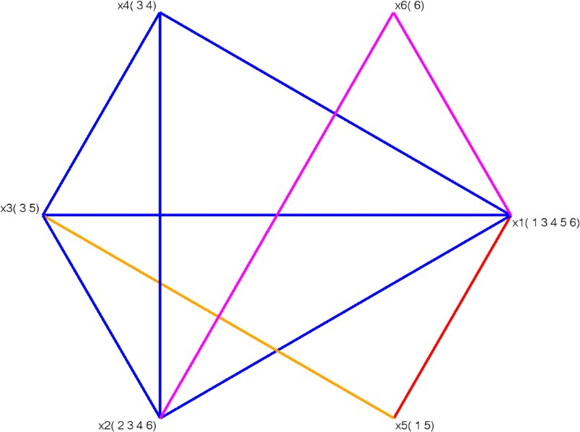

Figure 5. The operating model of the ZPx propositional function

The aim of modelling is to obtain a model of the structure, which solves a determined research prob- lem, that is, searching for actual costs of the appear- ance of risk factors in materials management within the logistic processes carried out. It is obtaining the result that requires limiting the structural model so that its Xi elements create a partially ordered set, that is, a set whose elements satisfy the partial order relation. Therefore, it is necessary to identify prohib- ited figures of the type QA and QB [5, 9, 13].

For the ZPx function, 4 prohibited figures of the type QA and 4 prohibited figures of the type QB were

The graphical representation of the figure is presented in the Fig. 6.

The analyzed function also contains 4 prohibited fig- ures of the type QB, which graphically are graph sub- models in the form of triangles with hanging vertexes. The identified figures of the QB type are:

*Q B* = {X1, X3, X2} {X1, X6} {X3, X5} {X2, X4}

1

*Q B* = {X1, X4, X2} {X1, X5} {X2, X6} {X4, X3}

2

*Q B* = {X1, X4, X3} {X1, X6} {X4, X2} {X3, X5}

3

*Q B* = {X , X , X } {X , X } {X , X } {X , X }

identified. The identified figures of the QA type are:

4 2 4 3

2 6 4 1 3 5

*Q A* = {X , X , X }

A graphical representation of the figure

*B* is pre-

1 1 3 5

*Q*

1

sented in Fig. 7.

*A* = {X1, X2, X3}

*Q*

2

*A* = {X1, X2, X4}

*Q*

3

*A* = {X1, X3, X4}

*Q*

4

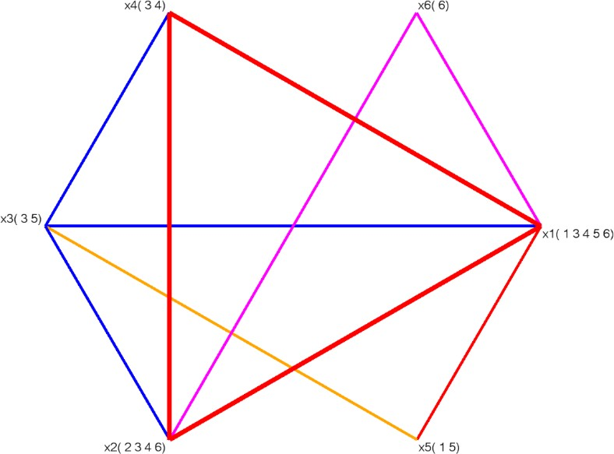

Figure 6. A graph model of functioning of the ZPx function with the marked prohibited graph figure of the type *Q A*

3

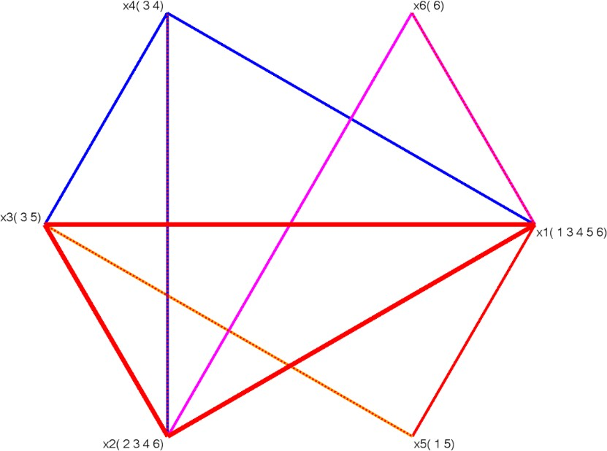

Figure 7. A graph model of the ZPx propositional function with a marked prohibited figure of the type *Q B*

1

Table 3. The semantic table of the ZPx function

|  |  |  |  |  |  |
| --- | --- | --- | --- | --- | --- |
|  | **X1** | **X2** | **X3** | **X4** | **X5** |
| *Q A*  1 | 1 | 0 | 1 | 0 | 1 |
| *Q A*  2 | 1 | 1 | 1 | 0 | 0 |
| *Q A*  3 | 1 | 1 | 0 | 1 | 0 |
| *Q A*  4 | 1 | 0 | 1 | 1 | 0 |
| *Q B*  1 | 1 | 1 | 1 | 0 | 0 |
| *Q B*  2 | 1 | 1 | 0 | 1 | 0 |
| *Q B*  3 | 1 | 0 | 1 | 1 | 0 |
| *Q B*  4 | 0 | 1 | 1 | 1 | 0 |

A semantic table was created in order to split the pro- hibited figures that appeared in the graph presentation of the analyzed propositional function (see Tab. 3).

It is in the first row of the table that the propositional variables are entered, which occurred in all identified prohibited figures. On the other hand, the prohibited figures are entered in the first column. In the following rows, we mark propositional variables with the digit 1 as vertexes of the prohibited graph figure, which ap- peared in the given prohibited figure (see Tab. 3). A minimal subset of propositional variables, which will cause elimination of all prohibited figures, is chosen on the basis of the frequency of the appearance of the propositional variables in the prohibited figures (the largest number of “1” in the column in the semantic table), as well as from the point of view of the cost analysis of logistic processes - among alternative solu- tions, we choose the ones, which represent the risk factors with the lowest probability (frequency) of the appearance and the lowest cost of potential effects.

In the analyzed function the propositional variable X1 combined with the propositional variables X2 or X3 or X4 or X5 causes splitting of all prohibited figures. The choice of the variables will determine the form of a new model of functioning ψ'a, and hence the form of the resultant Hasse diagram and the level of actual costs of the appearance of the risk factors in the process of the materials management in the examined enter- prise. Due to mathematical and economic reasons, the propositional variables X1, X2, X3, X4 and X5 were marked out for splitting. The form of the new model

'a is presented in Fig. 8.

As a result of splitting, the new operating model is obtained, Fig. 8, which corresponds with the appropri- ate Hasse diagram presented in the Fig. 9.

The new form of the ZP'x function:

ZPx(P1, P2,…,P52) = X1 X5 V X2 V X1 X2 X3 X'4 V X1 X'2 X4 V X1 X'3 X'5 V X'1 X2 X6

for which the latest operating model takes the following form:

M’ = < X’1 X2 X’3 X’4X5 X6 > R’1 = {{ X2}2 }

R’2 = {{ X1 X5 }1 }

R’3 = {{X1 X’2 X4}4, {X1 X’3 X’5}5, {X’1 X2 X6}6} R’4 = {{ X1 X2 X3 X’4 }3 }

After having analyzed the operating model, having identified prohibited figures and having analyzed the semantic table, the structural model was obtained. [5, 9, 12 and 13].

It is necessary to interpret the structural model in order to obtain information on actual costs caused by risk factors in the materials management of the examined enterprise. Based on this, it is known that the replicas of the variables X'1, X'3, X'4 were obtained. It has con- sequences for the calculation of the costs of the risk factors in the materials management within logistics processes carried out.

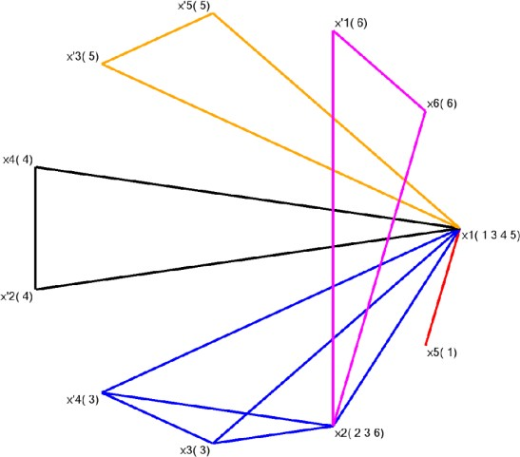

Figure 8. The new graph operating model 'a of the ZPx propositional function after splitting prohibited graph figures

X’1 (6) X6 (6)

X1 (1,3,4,6)

X2 (2,3,4,5)

X3 (3) X4 (4) X4 (5)

X5 (1) X’4 (3)

X’2 (4)

X’3 (5)

X1 (1,3,4,5)

Figure 9. A structural model b of the ZPx propositional function

Table 4. The analysis of the costs of the elimination of the individual risk factors for the selected propositional variables in the ψ'a operating model of the ZP’x function

|  |  |  |  |  |
| --- | --- | --- | --- | --- |
| **THE AREA OF THE APPEAR- ANCE OF RISK FACTORS** | **PROPOSITION- AL VARIABLE** | **2013** | | **QUANTITY * COST** |
| **QUANTITY** | **MAX COST** |
| SUPPLIES | X1 | 15 | 2,000 | 30,000 |
| X5 | 60 | 5,000 | 300,000 |
| PRODUCTION | X2 | 41 | 3,500 | 143,500 |
| DISTRIBUTION | X1 | 15 | 2,000 | 30,000 |
| X2 | 41 | 3,500 | 143,500 |
| X3 | 48 | 2,500 | 120,000 |
| X4 | 5 | 2,000 | 10,000 |
| X’4 | 5 | 2,000 | 10,000 |
| TRANSPORT | X1 | 15 | 2,000 | 30,000 |
| X2 | 41 | 3,500 | 143,500 |
| X’2 | 41 | 3,500 | 143,500 |
| X4 | 5 | 2,000 | 10,000 |
| STORAGE | X1 | 15 | 2,000 | 30,000 |
| X3 | 48 | 2,500 | 120,000 |
| X’3 | 48 | 2,500 | 120,000 |
| X5 | 60 | 5,000 | 300,000 |
| X’5 | 60 | 5,000 | 300,000 |
| MANAGEMENT LOGISTICS PROCESSES | X1 | 15 | 2,000 | 30,000 |
| X’1 | 15 | 2,000 | 30,000 |
| X2 | 41 | 3,500 | 143,500 |
| X6 | 10 | 20,000 | 200,000 |
| ∑ | | | | 2,387,500 |

It is in the Tab. 4, that the costs of risk factors were put together on the basis of the obtained new 'a operating model.

While comparing the total and actual costs of the ap- pearance of risk factors, it can be seen how important

it is to calculate them correctly. After examining a small number of risk factors, the difference amounted to PLN 603,500 - Tab. 5; it gives preliminary infor- mation on the scale of the phenomenon.

Table 5. The comparison of the total and actual costs of the elimination of effects of risk factors

|  |  |
| --- | --- |
| **BALANCE** | |
| **Total costs** | **Actual costs** |
| 1,784,000 | 2,387,500 |
| 603,500 | |

It was proven in the example that the characterization principle enables presenting a significant difference between total and actual costs of the appearance of risk factors in materials management within the logistic processes carried out. The difference in costs shown on the basis of the characterizations carried out indi- cates that not all expenses incurred in the enterprise were correctly categorized; it means that they were not correctly linked to the costs triggered by risk factors.

Not including actual costs of the appearance of risk factors may significantly affect errors in decision- making processes by giving an incorrect picture of the financial situation. Adding the false picture of the cre- ated value may consequently translate into worsening operational conditions of the enterprise in the market.

The consequences of underestimating costs associated with the elimination of the adverse effects of undesired events are visible in financial documents of the exam- ined enterprise.

The difference in costs presented on the basis of the characterizations carried out shows how many risk factors being found in one sphere of the enterprise af- fects other spheres, causing the so-called avalanche effects. It results from increasing costs of implementa- tion of processes.

After the analysis conducted with the use of the model based on the characterization principle, it can be seen that the actual costs of risks that is the ones that cover not only the elimination of the adverse effects of the events at the place of their appearance but also the ef- fects that occurred in other areas of the given process are considerably higher than the ones we were able to analyze while taking into account quantity and costs.

1. **Conclusions**

Materials management is one of the most important areas to be managed in the sense of searching for sav- ings in any enterprise. Many crucial elements of the materials management, the correct coordination

of which is translated into the net profit achieved by the enterprise, were indicated in the contents of this article.

The minimization of the costs in the area of the materi- al management means also implementing a risk man- agement system. The range of factors is really impressive here.

In the presented example the importance of correct cost accounting of the appearance of risk factors in the ma- terial management while manufacturing furniture - was shown. Not including the actual costs of the appearance of risk factors may significantly affect mistakes in deci- sion-making processes by giving an incorrect image of the financial situation. False picture of the created value added may consequently translate into deteriora- tion of operational conditions of the enterprise in the market.

1. **Bibliography**
2. Bowersox D.J. - *Logistics Strategic Planning for the 1990s* [at] Annual Proceedings of the Coun- cil of Logistics Conference, Oak Brook. Fall 1987.
3. Cooper M.C., Ellram L.M. - *Characteristics of Supply Chain Management and the Implication for Purchasing and Logistics Strategy* [in] *Interna- tional Journal of Logistics Management*, 2/1993.
4. Ellram L.M., Cooper M.C. - *Supply Chain Man- agement, Partnerships and the Shipper - Third Party Relationship* [in] *The International Journal of Logistics Management*, 2/1990.
5. Giunipero L.C., Brand R.C. - *Purchasing’s Role in Supply Chain Management* [in] *The Internation- al Journal of Logistics Management*, 1/1996.
6. Gorbatov V.A. - *Семантический теория дизайна автоматов*. Energia, Moskwa 1979.
7. Hergert M., Morris D. - *Accounting Data for Value Chain Analysis* [in] *Strategic Management Jour- nal*, III-IV1989.
8. Hewitt F. - *Supply Chain Redesign* [in] *The Inter- national Journal of Logistics Management,* 2/1994.
9. Johnson J.C., Wood D.F. - *Contemporary Logis- tics*. Macmillan Publishing Company, New York 1993.
10. Krupa T. - *Elementy organizacji. Zasoby i zadania* (*Elements of the organization. Resources and tasks*). WNT, Warszawa 2006.
11. Kulińska E. - *Risk management versus value of logistics processes* [in] *Advanced Logistics Solu- tions* (ed. V. Modrák). Technical Univercity of Košice, Prešov 2008.
12. Kulińska E. - *Wartość dla właścicieli a wartość dla klienta - metodyka analizy kosztów (The value for the owners and customer value - cost analysis methodology)* [in] *Zarządzanie kosztami podmio- tów gospodarczych* (ed.: W. Caputa, D. Szwajca). CeDeWu, Warszawa 2009.
13. Kulińska E. - *Aksjologiczny wymiar zarządzania ryzykiem procesów logistycznych. Modele i ek- sperymenty ekonomiczne (Axiological dimension of risk management of logistics processes. Eco- nomic models and experiments)*. Oficyna Wyd. Politechniki Opolskiej, Opole 2011.
14. Nazaretow W.M., Kim D.P., Krupa T. - *Technicz- na imitacja intelektu* ***(****Technical imitation of intel- lect)*. WNT, Warszawa 1991 (polish edition)***.***
15. Stevens G. - *Immigrating the Supply Chain* [in] The International Journal of Purchasing Distribu- tion and Materials Management, 19(8)/1989.